Opsc

Research on Three different Time Tracking Applications

Table of Contents
Introduction 5
Three Different time tracking applications for android 6
Overview of the applications 6
Strengths and weakness of the applications 10
Innovative features of the three-time tracking applications: 14
Infographic comparing the three applications (Similarities and differences) 16
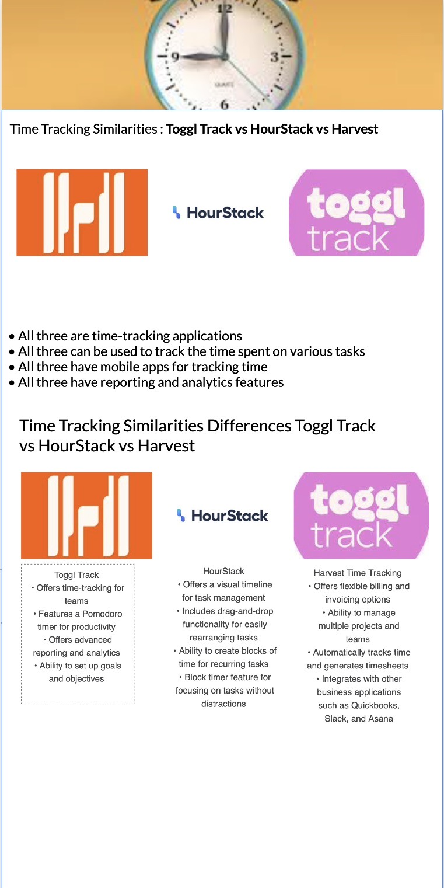 16
Features to be reconsidered in our own app 17
References 19

Research on Three different Time Tracking Applications

Introduction

Time-tracking software is used to record the amount of time employees spend on tasks or projects. The program is utilised by numerous sectors, including those that employ hourly and contract labour. It is also used by professionals who bill their clients per hour. They consist of independent contractors, attorneys, and accountants.
It is possible to utilise the time-tracking tool alone or in conjunction with other applications like project management, customer support, and accounting software. Time tracking software serves as the electronic equivalent of the traditional paper timesheet. Time-recording software employs user activity monitoring (UAM) to record computer activities and the amount of time spent on each project and work. Time-tracking software also includes timesheet software.

Various projects call for various methods of monitoring team productivity and tracking working hours. You may become a better project manager, increase your productivity, and boost project profitability with the aid of a solid project time tracking tool.

Apps for time and project management can greatly enhance corporate operations and promote business expansion.

benefits of time tracking applications
- You can track employee output to assist them in overcoming challenges at work and becoming more productive,
- It gathers timesheet information and keeps it in one easily accessible location.
- Real-time knowledge of the team's schedule allows for better project planning.
- Better workflow—tracking team members' time helps to better distribute work; you can see in real-time who is working on what, whether they are in-person or working remotely.

- More accurate forecasts for customer profitability and new projects — time reports provide detailed information about the hours spent on specific activities so that you may generate more accurate estimations,
- A better understanding of project performance - by keeping tabs on time usage, you can predict more accurately if your team will deliver work on schedule,
- You can control project profitability and make better business decisions for your employees and company—whether you charge enough money, have the right profit margin for products or services against the business costs, etc.\s*

Three Different time tracking applications for android

Overview of the applications

Harvest
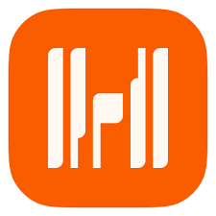

Harvest Time tracking applications is best for those who need to know where all the time and money spent on the project goes. It will answer all your questions concerning resources and budget in project management. Harvest is a simple time tracking app but offers many helpful features.

Main features
Tracking time in this tool tracks not only time but expenses, clients, projects, and task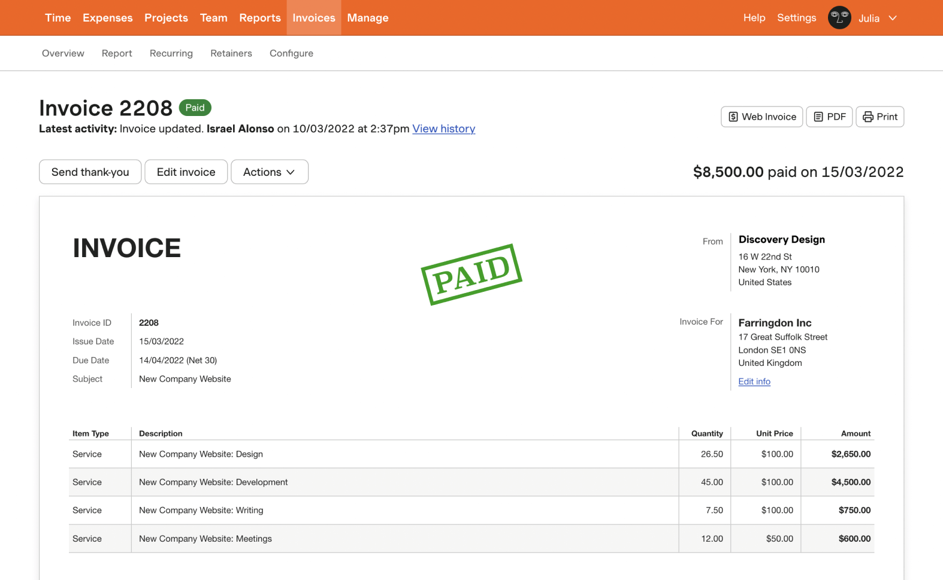
The timesheets in the visual form help you understand your team’s work and see how much time they spend on different tasks. You see how much, when, and on what tasks people are working.
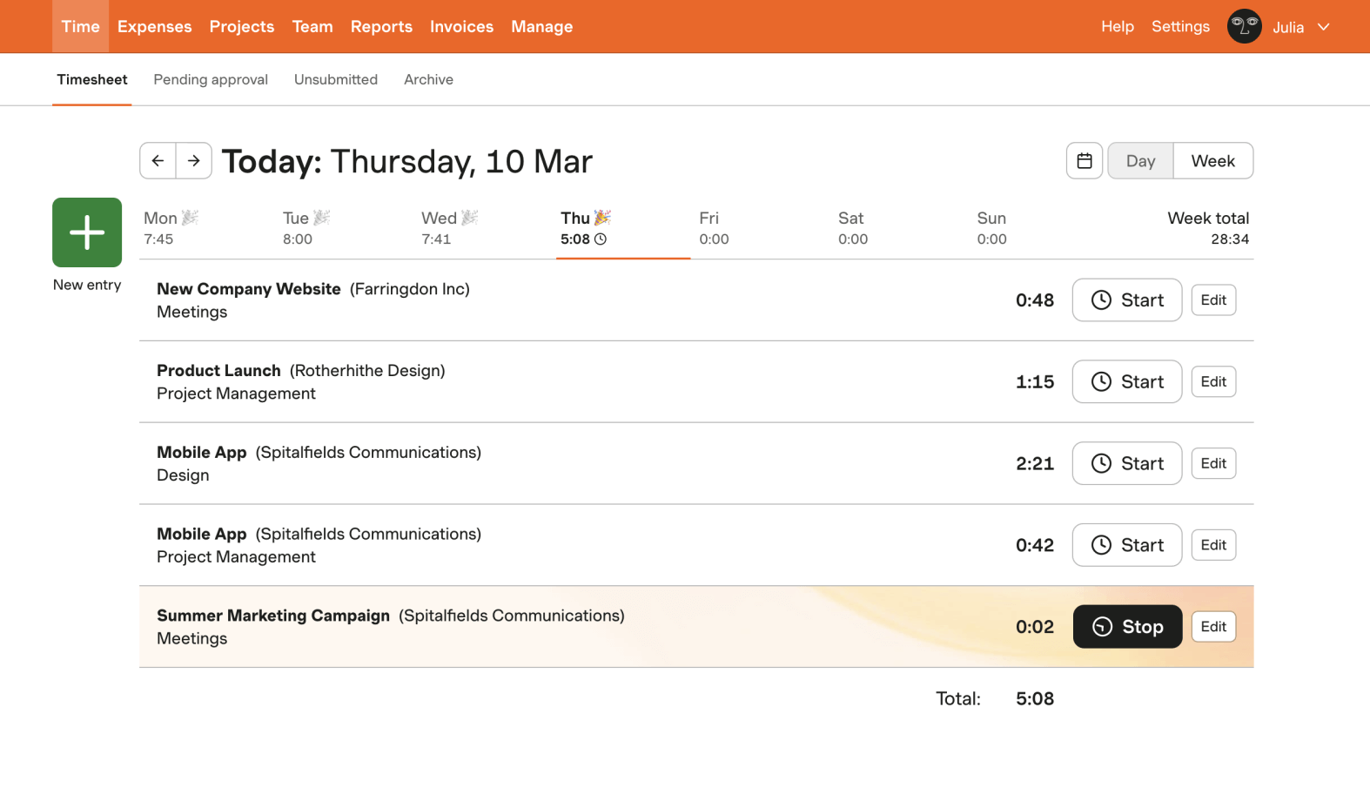
With extensive reports, you get information on every single aspect of your project: time spent, hours worked, budget, progress, time left to a deadline, etc.
Harvest allows you to integrate with Xero or QuickBooks to create invoices and quickly send them to your clients.
This simple project tracking tool software is available as a mobile app, web app, browser extensions, and for desktop.

Toggl Track
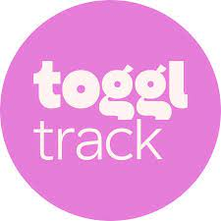

Toggl Track is a time tracking tool that has a generous free tier of service that gives you access to all its apps (Android, iOS, Windows, macOS, Linux, Web, and browser extensions). It includes all the core functionality you'd expect in a time tracking app, including detailed options such as idle detection and the Pomodoro Technique setting. Additionally, Toggl Track has Zapier integrations that allow you to start or stop time entries in Toggl Track when certain events start, add new time entries to a spreadsheet, and more.

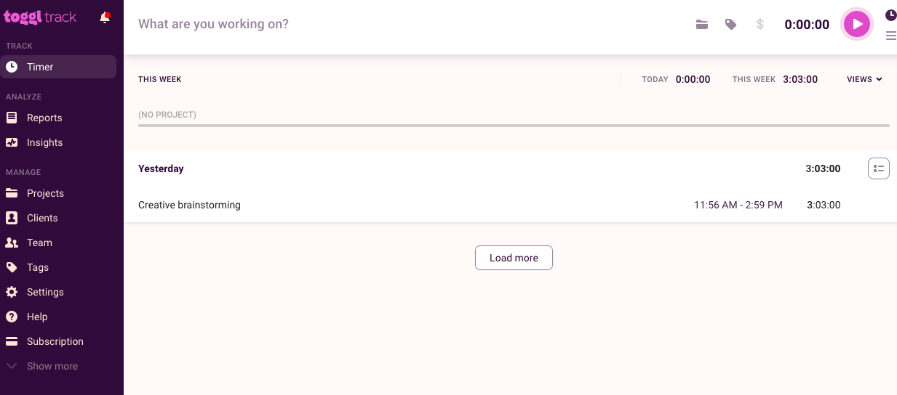

Main features of the application

- You can create projects.
- divide them into smaller tasks to develop blocks of work with due dates, assigned people, and any other adjustments that are most suitable for you.
- You can use this feature for deep work to improve productivity.

Hour Stack


is a combination calendar and time tracker that integrates smoothly with project management tools such as Asana, Google Tasks, Trello, Todoist, and Google Calendar. It has a sleek and easy-to-use interface and includes features such as a sidebar that displays tasks, drag and drop scheduling, and filterable reports. Additionally, Hour Stack has browser extensions for Chrome, Firefox, and Microsoft Edge that allow you to quickly add or start tracking project time without needing to input a task or project first. It also has Zapier integrations that allow you to complete Asana tasks when Hour Stack tasks are completed and more.

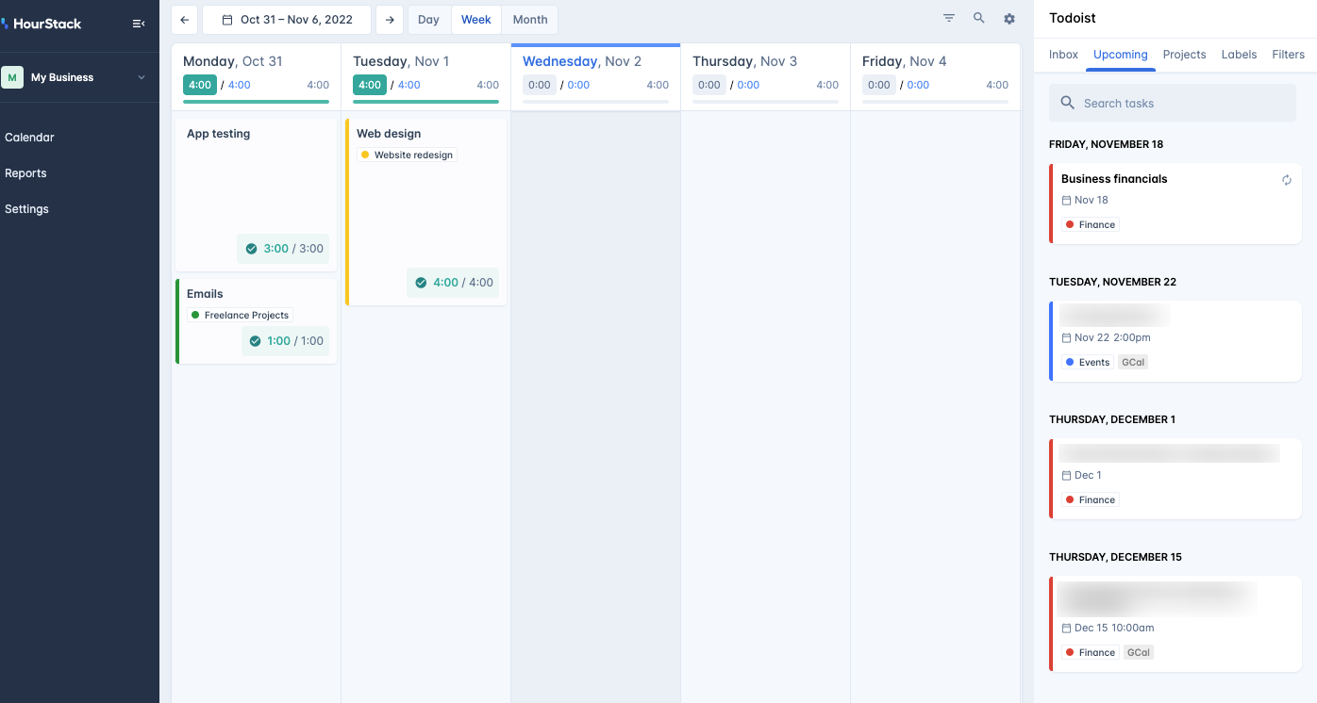

Strengths and weakness of the applications

Time tracking applications can have a good and bad effect on the company and its employees.

A basic overview of the strengths of time management applications in organizations

Accountability. Your team is held responsible for both what they have done and what they are meant to be doing thanks to time tracking software. You'll have written proof you can use to support disciplinary action or to suggest modifications to improve performance if you have a team member who consistently wastes time or who takes far longer than necessary to complete tasks.

Motivation. Time tracking can also be used to inspire your staff. With objective measurements, your staff members have a target to work toward and can track their progress. For instance, you could create a goal for your team to finish a project in 15 hours; if this goal is acceptable, your team members will put up a lot of effort to meet it.

Objectivity. A high-level performance assessment may be less objective than time tracking. Time tracking may show you precisely how much time your employees are spending on a task, as opposed to just noting specific behaviours or a history of qualitative performance difficulties. Also, you can utilize this data to support pricing increases and other internal adjustments.

Analytics. Finally, high-level analytical capabilities provided by time-tracking software allows you to compute the cost and value of your projects, the productivity of your personnel, and even the efficiency of your management approach. Having more knowledge on your side is virtually never a bad thing.
A basic overview of the weaknesses of time management applications in organizations

Paranoia. An employee's sense of wellbeing may be harmed by excessive workplace monitoring. They can believe that their every move is being monitored and that as a result, their surroundings are less warm and inviting. In the end, this can lead to decline.

Reliability. Not every time-tracking tool is ideal. You can lose data on an important project if your platform is out for a day. You might not be able to produce the high-quality data required to draw reliable conclusions if your staff aren't using the platform consistently.

Manipulation. Employees can manually enter their time or make changes to previously registered time on most time-tracking solutions. As a result, it is possible to manipulate your data.

Strengths and weaknesses: Harvest


Best for: time tracking with expense.

- This simple project tracker software is available as a mobile app, web app, browser extension, and desktop.
- With extensive reports, you get information on every single aspect of your project: time spent, hours worked, budget, progress, time left to a deadline, etc.
- Visual timesheets help you understand your team's work and see how much time is spent on different tasks. See when and how much work is being done on which task
- Tracking time in this tool tracks not only time but expenses, clients, projects, and tasks

Weaknesses for harvest
- Missing batch- assign functionality
- Timer-on notification (notifications are set manually)
- Both Android and Desktop app to web app disconnection
- The UI is not user friendly.
- The application has a slow response time.
- There is no counter on the app icon to show whether it's running or not.

Strengths and weaknesses: Toggl track strengths

Toggl Track Strengths:
- Simple and easy to use for basic time tracking and reporting.
- Offers access to all its apps (Android, iOS, Windows, macOS, Linux, Web, and browser extensions)
- Can track time right away, view tracked time entries in a grid or calendar format -Toggl timer button shows up in almost every web app.
- Excellent idle detection
- Pomodoro setting
- Zapier integrations to connect with other apps.

Toggl Track Weaknesses:
- No granular insights, saved reports, or billable hours unless you upgrade too Premium.
- No task management or planning feature.

Strengths and weaknesses: Hour Stack

Hour Stack Strengths:

- Native integrations with popular project management tools like Asana, Google Tasks, Trello, Todoist, and Google Calendar

- Integrations work both ways -Sleek and easy-to-use combination calendar and time tracker.

- Simple and does not overload or distract with complicated settings or interfaces -Browser extensions for Chrome, Firefox, and Microsoft Edge

- Zapier integrations to connect with other apps.

Hour Stack Weaknesses:
- No desktop or mobile app

- Limited points of access

Innovative features of the three-time tracking applications:

Harvest:

Tracking time in this tool tracks not only time but expenses, clients, projects, and tasks
The timesheets in the visual form help you understand your team’s work and see how much time they spend on different tasks. You see how much, when, and on what tasks people are working.
With extensive reports, you get information on every single aspect of your project: time spent, hours worked, budget, progress, time left to a deadline, etc.

Toggl Track:

Toggl Track has idle detection, the Pomodoro Technique setting, and Zapier integrations that enable users to start or stop time entries in Toggl Track when certain events start or add new time entries to a spreadsheet.

Hour Stack:

Hour Stack has a sleek and easy-to-use interface, native integrations with popular project management tools, and browser extensions for Chrome, Firefox, and Microsoft Edge. It also has Zapier integrations that allow users to complete Asana tasks when Hour Stack tasks are completed.

Infographic comparing the three applications (Similarities and differences)

Features to be reconsidered in our own app
- User-friendly
- Track time
- Quick insight into projects and other various status
- Invoice clients
- Intuitive interface design
- Work schedule management tool
- The user shall be able to backup and restore their Data.
- The user interface will not be cluttered and it will be relatively straightforward and easy to navigate.
- The user can analyse work hours by chart.
- Visual timesheets help you understand your team's work and see how much time is spent on different tasks. See when and how much work is being done on which task.
- Multiple Project Support
- Automatic Tracking
- Billing & Invoicing
- Reporting & Analytics
- Client/Project Management
- Mobile Application
- Collaboration Tools
- ] Offline Support
- Time Zone Support
- Project Costing
- Time Sheet Approvals

Conclusion

There are many reasons for tracking time. The landscape of work has changed dramatically, so we need to rely on as much data as possible. Especially as we transition to mostly remote work. Time tracking is one of the most reliable ways to maintain stability in your work. It helps organize work, identify problem areas, and provide information about how much time employees and employers spend in their workdays.
Time tracking is an essential work tool that has stood the test of time and is the most versatile weapon for survival in the modern workplace.

References

Borucka, K. (2022). 13 Best Tools for Project Time Tracking - project management trackers. [online] TimeCamp. Available at: https://www.timecamp.com/blog/2022/09/best-tools-for-project-time-tracking/#What_Is_Project_Time_Tracking
[Accessed 15 Mar. 2023].
The history of Time Tracking + Best Ways to track work hours (2022) actiTIME. Available at: https://www.actitime.com/time-tracking/time-tracking-software-essay (Accessed: March 15, 2023).
Borucka, K. (2023) 13 best tools for project time tracking - project management trackers, TimeCamp. Available at: https://www.timecamp.com/blog/2022/09/best-tools-for-project-time-tracking/#4_Harvest (Accessed: March 15, 2023).
Borucka, K. (2023) 13 best tools for project time tracking - project management trackers,

